ROUND 3
FLAGS
Answer the questions below regarding the flags pictured.

- Which African country does this flag belong to?
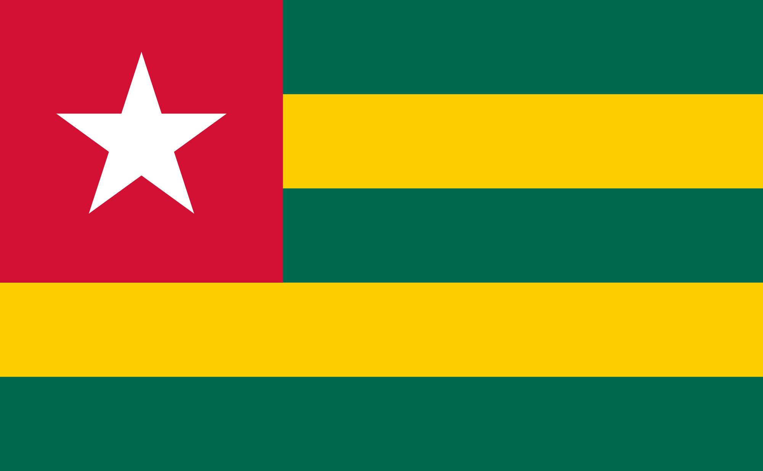

- This was the reverse side of which country’s flag until 1974?
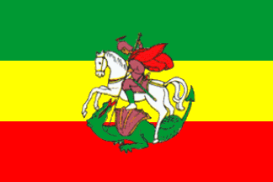

- To which former UK colony did this flag belong?
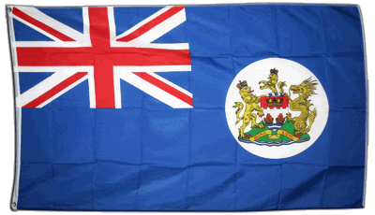

- This flag belongs to which country?

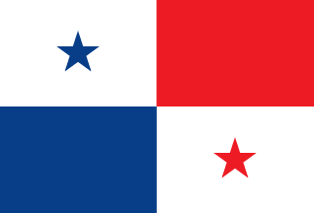

- This flag belongs to the 58th most populous city in USA, name that city.
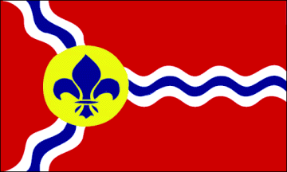

- This was the flag adopted by a breakaway Republic in Central America in the 1840s, it shares its name with a major board game publisher. Name the abortive Republic.
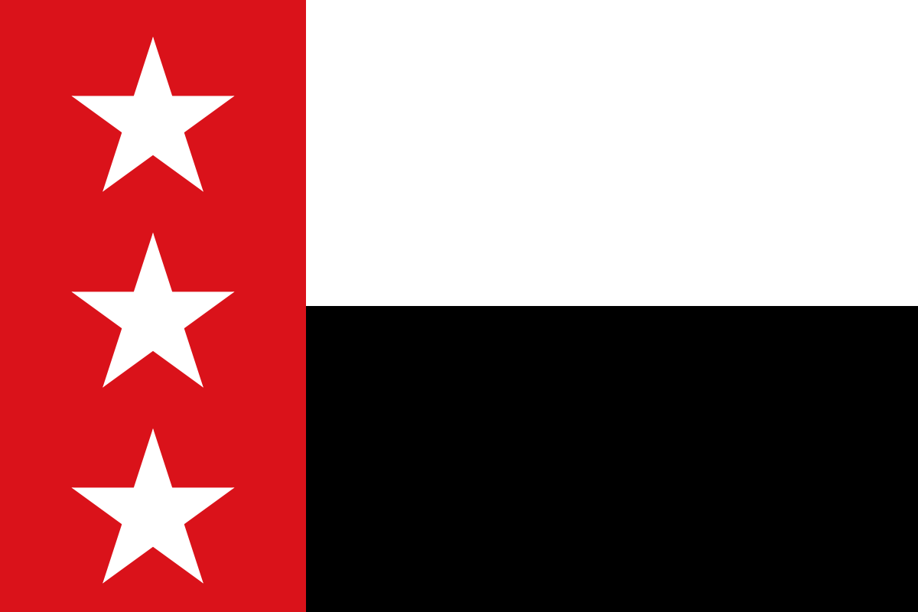

- To which country does this flag belong?
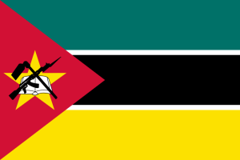

- To which country does this flag belong?
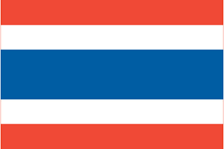

- To which English county does this flag belong?
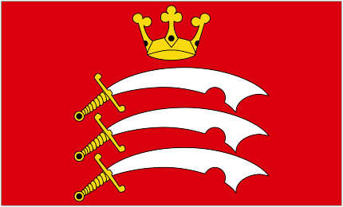

- To which English county does this flag belong?
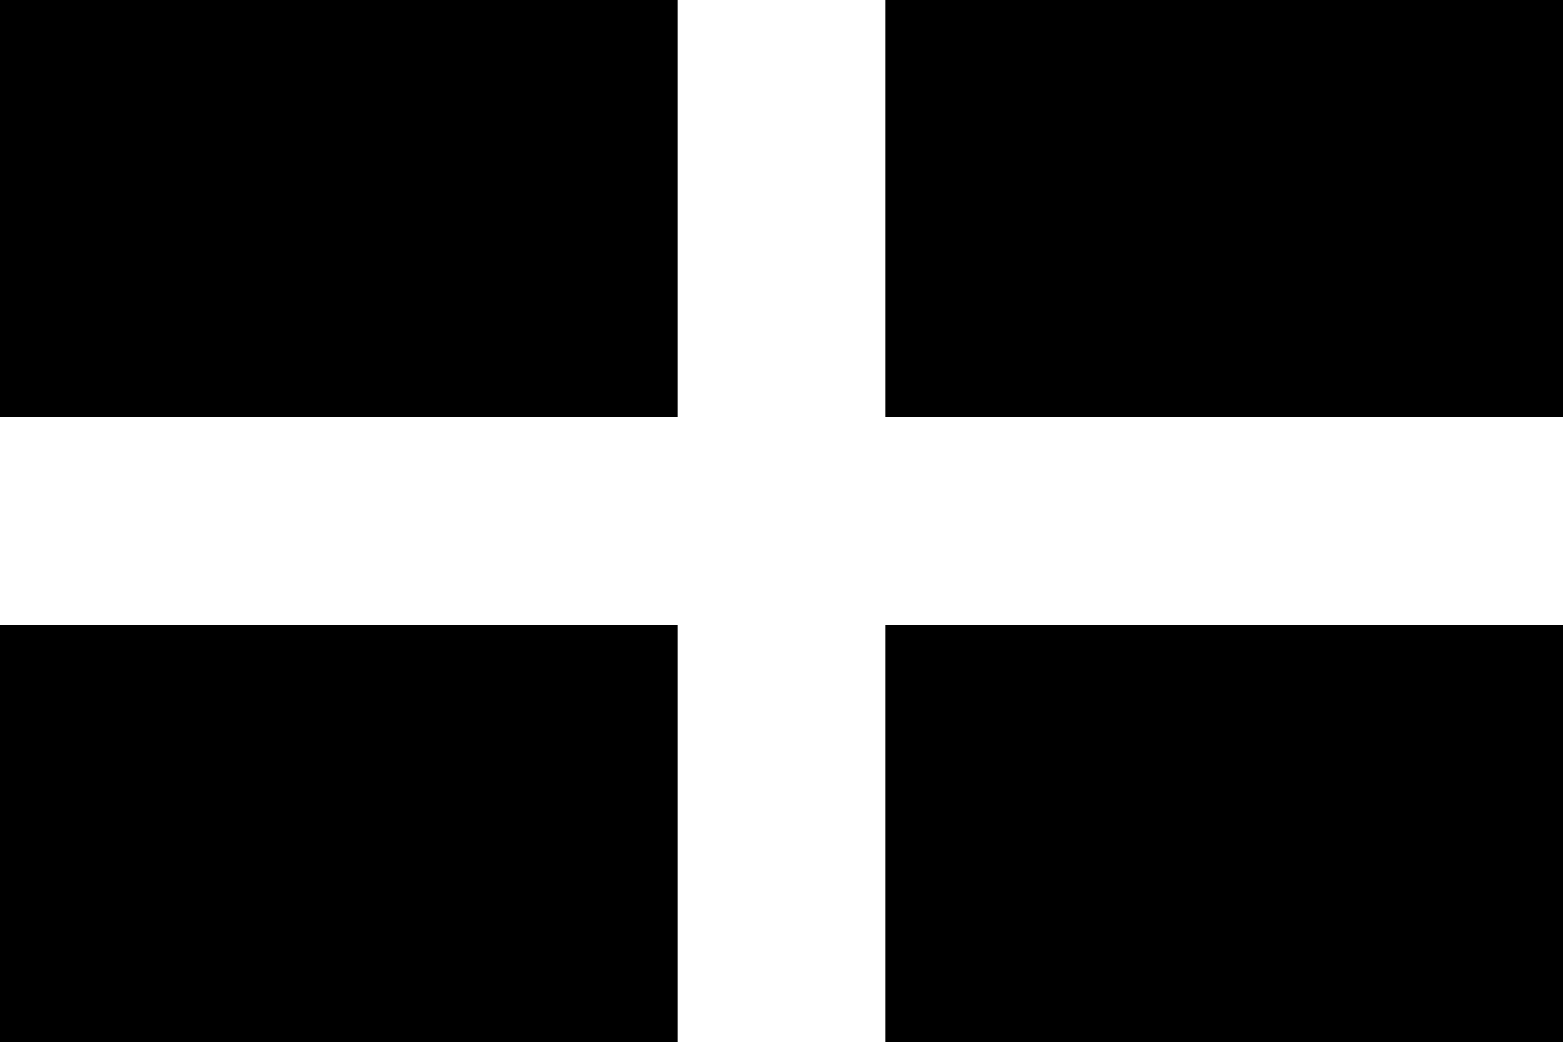

- To which country does this flag belong?
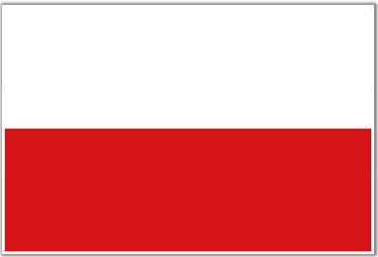

- Which of these is true with regards to the flag below?
- Oldest National flag still in use
- Only national flag which is also the head of state’s family banner
- Only national flag to have started use as the flag of another country
- Only flag other than USA’s to have been flown from The White House

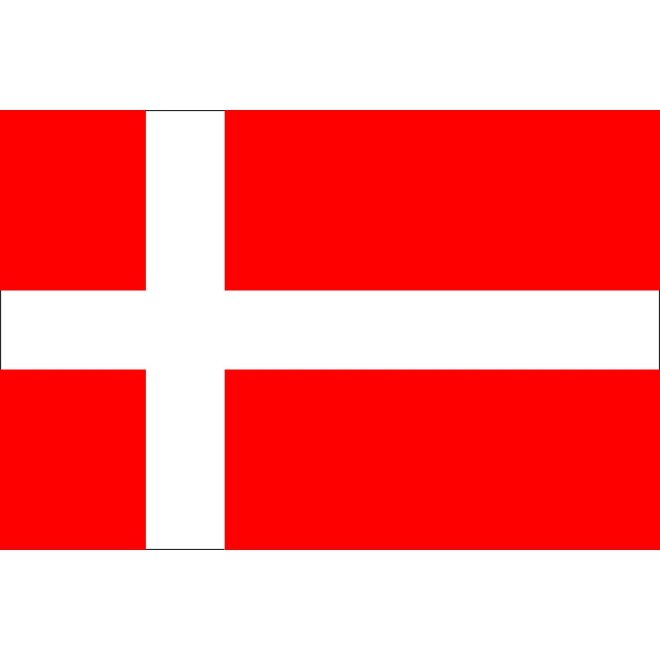

- In what year was this flag adapted as the official flag of the country?
- 1556
- 1606
- 1656
- 1706
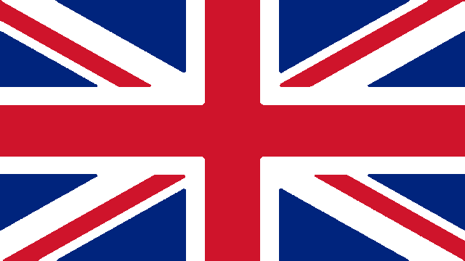

- This flag is still flown from the oldest what in the USA?
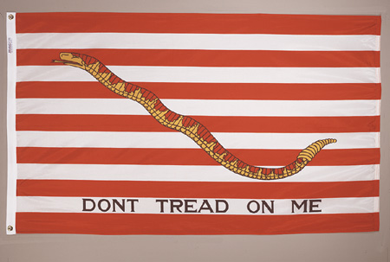

- This is the newest national flag in Europe, to which nation does it belong?
